**ASSIGNMENT SUBMISSION COVER SHEET**

Cse24-028

**Student Id:**

**Student names:**

Botho Pamela Merafhe

**Student email:**

Cse24-028@thuto.bac.ac.bw

**Cohort:**

Cse24

Part – A System documentation

**Assignment title:**

**Date of submission:**

19 September 2025

**Programme of**

Computer Systems Engineering

**Study:**

Year 2

**Year of Study:**

**Intellectual property statement**

**By checking the box below, I certify that this assignment is my own work and is free from**

**plagiarism. I understand that the assignment may be checked for plagiarism by**

**electronic or other means and may be transferred and stored in a database for the**

**purposes of data-matching to help detect plagiarism. The assignment has not previously**

**been submitted for assessment in any other unit or to any other institution. I**

**have read and understood the Botswana Accountancy College plagiarism guidelines**

**policy.**

**☐ Agree Signature…………***b.p.merafhe***………………………….**

**Date…**19/09/2025**………………………………………**

**REQUIREMENTS ELICITATION**

**Functional Requirements**

The banking system must provide the following functionalities:

1. Customer Registration and Authentication

Customers need to register using their personal details (first name, last name, address, etc.).

Customers must authenticate (e.g., username & password / PIN) prior to accessing the account.

Authentication must be performed for sensitive transactions such as withdrawals, account closing, and viewing transaction history.

2. Account Management

Open new accounts (Savings, Investment, Cheque).

Provide multiple accounts for a customer.

Close an account upon request by the customer.

3. Deposits and Withdrawals

Deposit into any account.

Withdrawals (with account limitations, i.e., Savings does not allow withdrawal).

Minimum deposit for Investment accounts.

4. Interest Calculation

Charge automatic monthly interest:

5% for Investment Accounts ,0.05% for Savings Accounts.

5. Transaction History

Log and display all deposits, withdrawals, and interest paid.

Display customers' transaction history upon authentication.

**NON-FUNCTIONAL REQUIREMENTS**

Non-functional requirements describe how the system must be.

1. Performance

System must be capable of processing several transactions simultaneously effectively

-Interest calculations need to be calculated monthly without any delay

2. Security

-Store customer information securely

- Prevent unauthorized access

3. Usability

-Customer-friendly user interface to view accounts and transactions

-Easy navigation to control accounts

4. Reliability

-System must ensure data integrity

-The transactions must be accurately recorded

5. Maintainability

-Code structure should allow easy updates (OOP principles: inheritance, polymorphism, encapsulation, etc.)

**STRUCTURAL UML MODELLING**

SYSTEM USE CASE DIAGRAM

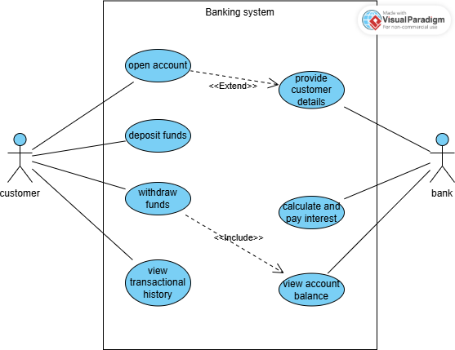

CLASS DIAGRAM

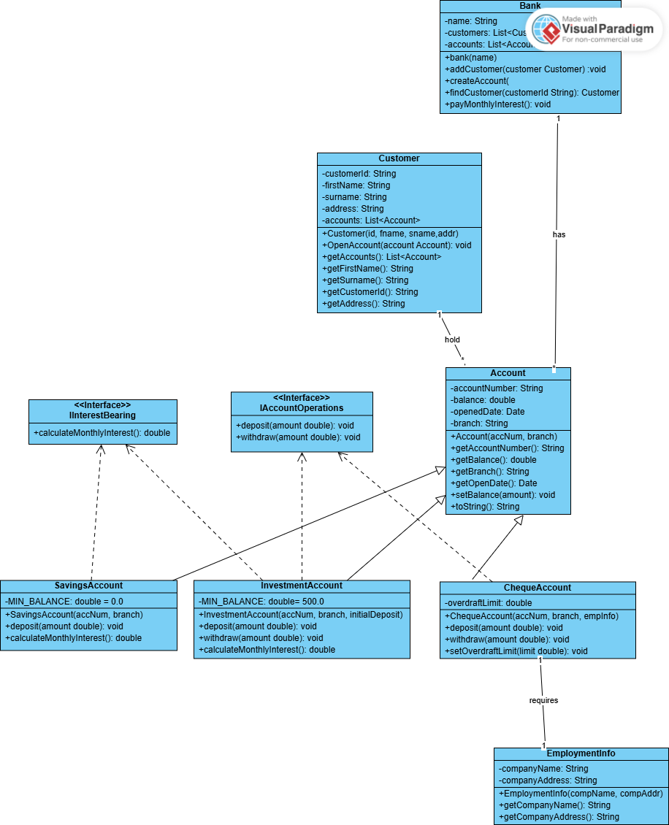

**BEHAVIOURAL UML MODELLING**

LOGIN SEQUENCE DIAGRAM

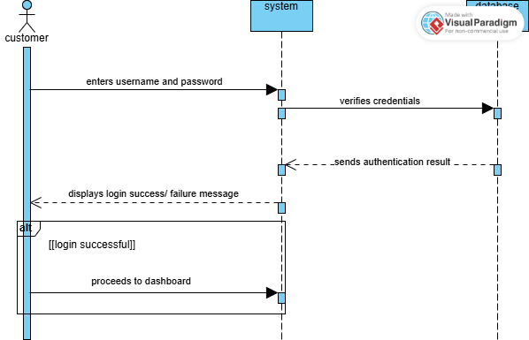

DEPOSIT SEQUENCE DIAGRAM

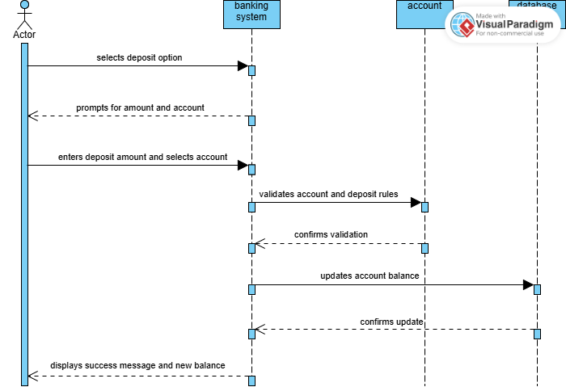

STATE DIAGRAM

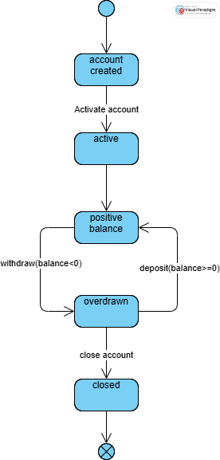

**MEETING RECORD APPENDIX**

Interviewer: Botho Pamela Merafhe

Interviewee (client): Mr Kentsenao Baseki

Date : 18 September 2025

Time: 09: 30 – 10:30

Place of interview: online

Good morning, I am Botho Merafhe and I’m working on developing a banking system as my project. The purpose of this interview is to understand your needs, expectations and how the system should function from your perspective.

1. Can a customer hold multiple accounts?

-Yes a customer can have multiple accounts, but the customer cannot have multiple accounts of the same type

2. What is involved when a customer wants to open an account?

-Opening an account includes capturing customer details. This is part of the account opening process and must be handled in the system.

3. Is the customer responsible for entering their own details when opening an account?

- No, the customer does not capture their own details. Someone from the bank (bank employee) handles that part.

4. What are the main functions the customer should be able to perform

- The customer should be able to login, view their balance, withdraw, make deposits and view transactional history

5. What are the different types of accounts customers can open in the system?

- Customers can open different account types, including individual and company accounts. These accounts are savings, investment and cheque account.

6. Are all accounts allowed to perform withdrawals?

- No, some accounts have restrictions. Savings account does not allow withdrawals

7. Should the system validate the initial amount when opening accounts?

- Yes, the system must check initial amount during account creation. If the amount is below the required minimum amount, it should display an error and reject the transaction

8. Should the system automatically calculate and apply monthly interest, or this will be handled manually by the staff

- The system should automatically calculate and apply monthly interest